

Low Level Concerns
Policy

September 2024

Contents
1. Introduction
2. Summary
3. Keeping Children Safe in Education September 2024
4. Clarity around Allegation vs Low-Level Concern vs Appropriate Conduct
5. Storing and use of Low-Level Concerns and follow-up information
6. Process to follow when a Low-Level Concern is raised
7. Low Level Concern Form

Introduction
At St. Saviour’s C of E Primary School, we take safeguarding very seriously. This includes ensuring that adults who work with children do so in a way that is in accordance with the ethos and policies set out by the school, including the Staff Code of Conduct. This policy sets out the detail and processes for staff regarding low-level concerns they may have.
Summary
It may be possible that a member of staff acts in a way that does not cause risk to children, but is however inappropriate. A member of staff who has a concern about another member of staff should inform the Head Teacher about their concern either verbally or by using a Low-Level Record of Concern Form (appendix A) or via our safeguarding portal My Concern: Confide. If the Head Teacher cannot be contacted, the Deputy Head or Chair of Governors should be contacted instead.
Keeping Children Safe in Education September 2024
Section two: Concerns or allegations that do not meet the harm threshold
430. Governing bodies and proprietors should have policies and processes to deal with any concerns or allegations which do not meet the harm threshold, referred to in this guidance as ‘low-level’ concerns. It is important that schools and colleges have appropriate policies and processes in place to manage and record any such concerns and take appropriate action to safeguard children.
Low-level concerns 431. As part of their whole school or college approach to safeguarding, schools and colleges should ensure that they promote an open and transparent culture in which all concerns about all adults working in or on behalf of the school or college (including supply teachers, volunteers and contractors) are dealt with promptly and appropriately.
432. Creating a culture in which all concerns about adults are shared responsibly and with the right person, recorded and dealt with appropriately, is critical. If implemented correctly, this should:
• enable schools and colleges to identify inappropriate, problematic or concerning behaviour early
• minimise the risk of abuse, and
• ensure that adults working in or on behalf of the school or college are clear about professional boundaries and act within these boundaries, and in accordance with the ethos and values of the institution
What a low-level concern is:
433. The term ‘low-level’ concern does not mean that it is insignificant. A low-level concern is any concern – no matter how small, and even if no more than causing a sense of unease or a ‘nagging doubt’ - that an adult working in or on behalf of the school or college may have acted in a way that:
• is inconsistent with the staff code of conduct, including inappropriate conduct outside of work, and
• does not meet the harm threshold or is otherwise not serious enough to consider a referral to the LADO.
Examples of such behaviour could include, but are not limited to:
Being over friendly with children; having favourites; taking photographs of children on their mobile phone, contrary to school policy; engaging with a child on a one-to-one basis in a secluded area or behind a closed door, or humiliating children.
434. Such behaviour can exist on a wide spectrum, from the inadvertent or thoughtless, or behaviour that may look to be inappropriate, but might not be in specific circumstances, through to that which is ultimately intended to enable abuse.
435. Low-level concerns may arise in several ways and from a number of sources. For example: suspicion; complaint; or disclosure made by a child, parent or other adult within or outside of the organisation; or as a result of vetting checks undertaken.
436. It is crucial that all low-level concerns are shared responsibly with the right person and recorded and dealt with appropriately. Ensuring they are dealt with effectively should also protect those working in or on behalf of schools and colleges from becoming the subject of potential false low-level concerns or misunderstandings.
Reporting a low-level Concern:
This can be done via My Concern: confide or via form (appendix A).
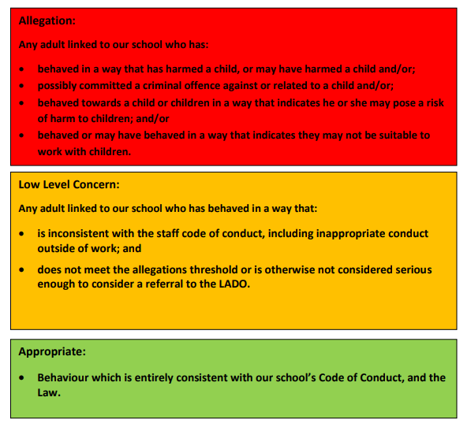
Clarity around Allegation vs Low-Level Concern vs Appropriate Conduct

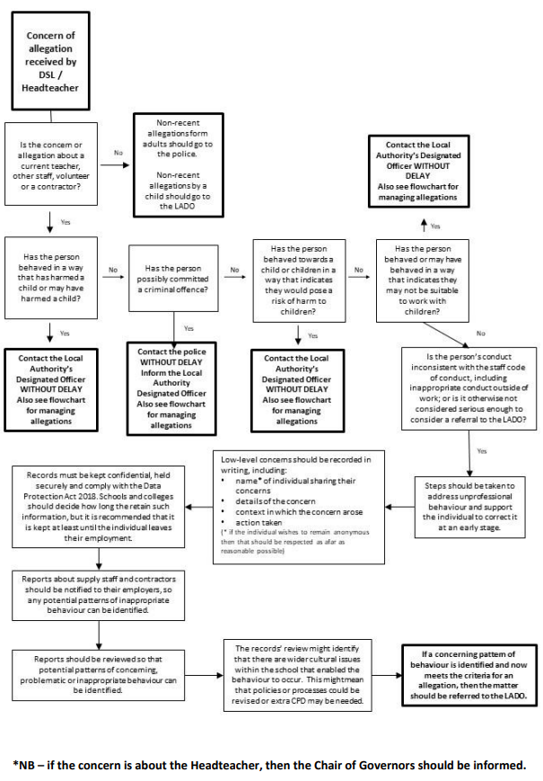

Storing and use of Low-Level Concerns and follow-up information
Low Level Concerns forms and follow-up information will be stored securely within the schools safeguarding systems, with access only by the senior leadership team. This will be stored in accordance with the school’s GDPR and data protection policies. The staff member(s) reporting the concern must keep the information confidential and not share the concern with others apart from the Head Teacher or those aware in the senior leadership team.
Low-Level Concerns will not be referred to in references unless they have been formalised into more significant concerns resulting in disciplinary or misconduct procedures. Whenever staff leave St. Saviour’s C of E Primary School, any record of low-level concerns which are stored about them will be reviewed as to whether or not that information needs to be kept.
Consideration will be given to:
(a) whether some or all of the information contained within any record may have any reasonably likely value in terms of any potential historic employment or abuse claim so as to justify keeping it, in line with normal safeguarding records practice; or
(b) if, on balance, any record is not considered to have any reasonably likely value, still less actionable concern, and ought to be deleted accordingly.

APPENDIX A: Low Level Concern Form
This form can be used to share any concern with Headteacher/Chair of Governors, no matter how small or seemingly insignificant, even if no more than causing a sense of unease or a ‘nagging doubt’ – that an adult may have acted in a way that is inconsistent with the Schools’ Code of Conduct [including inappropriate conduct outside of work] and/or in a way that on first glance does not appear to meet the allegation, ‘harm’ threshold.
A concise record is required, including brief context in which the low level concern arose, plus details which are chronological, precise and as accurate as possible, of any such concern and /or relevant incident[s]. [Continue on separate sheets as necessary]. The form should be signed, timed and dated.
Your details:
Name (optional) :
Role:
Date & time of completing form:
Details of individual:
Name:

Role:

Details of Concern:
Please include as much detail as possible. Think about the following: What behaviour and/or incident are you reporting? What exactly happened? Why does the behaviour and/or incident worry you? Why do you believe the behaviour and/or incident is not consistent with our Staff Code of Conduct?

Signature:
For use by HT/safeguarding team upon receipt of the concern
Date & time concern received:
Signature:
Role:
Actions to be taken & follow up:

