English
This term we will be focusing on:
Writing to Persuade
Writing to Entertain
The writing outcomes will include:
- Narrative (Dialogue)
- Character description
- Setting description
- Letter
- Diary (Recount)

Guided Reading

This term we will be reading:

The Diary of a Killer Cat.

Iron Man
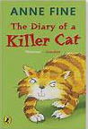

Maths
In Maths this term, we will be focusing on the following topics:
Number: Multiplication and Division (B)
Reasoning about multiplication
Multiply a 2-digit by a 1-digit (exchange and no exchange)
Divide a 2-digit by a 1-digit (with remainders)

Measurement: Length and Perimeter
Measure in millimeters, centimetres and metres
Equivalent lengths
Add, subtract and compare lengths
Measure and calculate length

Number: Fractions (A)
Unit and non-unit fractions
Count in fractions on a number line
Equivalent fractions

Measurement: Mass and Capacity
Measure mass in grams and kilograms
Add, subtract and compare mass
Measure capacity and volume in millilitres and litres
Add, subtract and compare capacity and volume

This curriculum map provides an overview of what your child will be learning across the curriculum this term. Wherever possible, learning will be linked to our focus topic.

Enrichment Opportunities

Maths Workshop.

Think Tank Museum
Year 3 Curriculum Map
Spring Term
Topic: A Journey
Through Time

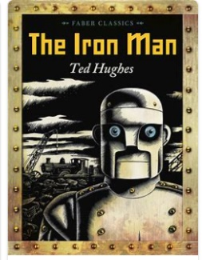

History
Children will learn about the Stone Age to Iron Age (Stone Age, Bronze Age, Iron Age and Celtic Culture).

Science
The topics this term are ‘Rocks and Fossils’ and ‘Plants’.

Design and Technology
Children will be learning ‘Structures: Constructing a building’.

Computing
Children will learn about ‘Programming: Scratch’ and about ‘Creating Media’.

PE
The topics for this term are ‘Gymnastics’ and ‘Invasion Games’ - Cricket.
RE
The two themes we will be looking at this term are ‘Jesus Miracles’ and ‘Easter’.

For the topics, the children will be exploring two key questions: ‘Could Jesus heal people? Were these miracles or is there some other explanation?’ and ‘What is good about Good Friday?’

RSHE
The topics this term are ‘KiVa’ – our school’s antibullying scheme and ‘Identity, society and equality: Celebrating Differences’.

Art
Children will be looking at pre-historic paintings and mixed media.
Music
Children will learn a song called ‘Three Little Birds’, ‘The Dragon Song’ and learn how to play the Glockenspiel.

MFL
In Modern Foreign Language, children will learn to say simple phrases all about them in French.

