 | AUTUMN | SPRING | SUMMER
Year 1 | What is it like here?  Where in the world are we?  What can we see in our classroom?  What can we find in our school grounds?  Where are the different places in our school?  How can I use simple directional language to locate an object? | How does the weather affect us?  Where is the UK?  What are the four seasons?  What are compass directions?  What is the weather like today?  Is the weather the same in everywhere in the UK?  How do people prepare for the weather? | What is it like to live here?  Name and locate the countries of the United Kingdom.  Where do we live in the UK?  Explain the differences between a ‘town’ and the ‘countryside’ (ODDIZZI)  What can we see in our local area? (Physical & human features)  Can we map our local area?  What landmarks are there in Birmingham?  Fieldwork: traffic outside our school
Geographical skills and fieldwork
- use world maps, atlases and globes
- use locational and directional language
- devise a simple map; devise symbols in a key
- use simple fieldwork and observational skills to study the geography of school and grounds and the key human and physical features of its surrounding environment.
KEY VOCAB | ● village ● town ● city ● land ● lake ● river ● ocean ● sea ● place ● continent ● country | ● weather ● season ● climate ● Europe ● England ● Scotland ● Wales ● Northern Ireland ● United Kingdom (UK) | ● village ● town ● city ● country
Year 2 | Would you prefer to live in a hot or cold place?  Where are the continents?  Where are the coldest places on Earth?  Where is the equator?  What is life like in a hot place? Pakistan/ Australia  Do we live in a hot or cold place?  Would you prefer to live in a hot or cold place? | Why is our world wonderful?  What are some of the UK’s amazing features and landmarks?  Where are some of the world’s most amazing places?  Where are our oceans?  What is amazing about our local area?  Where in the world is Australia?  What can you see in Australia? (physical/human features)  How is it different from our local area? | What is it like to live by the coast?  Where are the seas and oceans surrounding the UK?  What is the coast?  What are the physical features of Weston Super Mare  How do people use Weston (human features)?  Fieldwork: seaside trip  ODDIZZI- virtual fieldwork  KS1 A SEASIDE ADVENTURE  *Launching May 2024*
KEY VOCAB | urban ● rural ● pack ice ● ice sheet ● arid ● savannah ● vegetation ● grasslands ● rainforest ● polar ● mild ● temperate | ● habitat ● Atlantic Ocean ● Indian Ocean ● Southern Ocean ● Pacific Ocean ● Arctic Ocean ● capital city | ● aquarium ● tourist ● arch ● bay ● coast ● mudflat ● pier ● cliff ● coastline ● island ● sand dunes ● stack
Geographical skills and fieldwork
- use world maps, atlases and globes
- use aerial photographs and plan perspectives
- use simple compass directions (N,S,E,W)
- use simple fieldwork and observational skills study the key human and physical features
Year 3 | Are all settlements the same?  To describe different types of settlements.  Can I explain the location of features in my local area?  How has Birmingham changed over time?  How is land used in New Delhi?  How does land use in New Delhi compare with my local area?  Fieldwork: Features of the local area | Who lives in Antarctica?  What is climate?  Where is Antarctica?  Who lives in Antarctica?  Who was Shackleton?  Can we plan an expedition around school?  How did our expedition go?  Virtual Fieldwork- ODDIZZ!  Explore Antarctica part 1 & part 2 | Where does our food come from?  How can our food choices impact the environment?  What does it mean to trade responsibly?  How do we get our chocolate? (John Cadbury- Birmingham link)  Where does our food come from?  Are our school dinners locally sourced?  Is it better to buy local or imported food?
Geographical skills and fieldwork
- use maps, atlases, globes and digital/computer mapping to locate countries and describe features studied
- use fieldwork to observe, measure, record and present the human and physical features in the local area using a range of methods, including sketch maps, plans and graphs, and digital technologies
KEY VOCAB | ● linear ● nucleated ● dispersed ● recreational land ● agricultural land ● residential land ● commercial land ● place of worship ● monument ● memorial ● facilities ● settlement ● county ● region ● local ● country border | ● treaty ● ice shelf ● drifting ice ● iceberg ● wilderness ● Tropic of Capricorn ● Tropic of Cancer ● Northern Hemisphere ● Southern Hemisphere ● Arctic Circle ● Antarctic Circle | ● food miles ● import ● export ● distribution ● produce ● waste ● consume ● fertilisers ● pesticides ● greengrocer ● butcher ● trade ● product ● cooperative ● responsible trade ● seasonal food ● air freight ● grant packaging ● bakery ● food bank ● allotment
Year 4 | Why do people live near volcanoes?  How is the Earth constructed?  Where are mountains found?  Why and where do we get volcanoes?  What are the effects of a volcanic eruption?  What are earthquakes and where do we get them?  European regions: Italy & Greece (History links)  Locate the world’s countries, using maps to focus on Europe (including the location of Russia) and North and South America, concentrating on their environmental regions, key physical and human characteristics, countries, and major cities. | Why are rainforests important to us?  Where in the world are tropical rainforests?  What is the Amazon rainforest like?  Who lives in the rainforest?  How are rainforests changing?  To explain deforestation in Pakistan  To use computer mapping to locate areas of deforestation | What are rivers and how are they used?  What is the water cycle?  How is a river formed?  Where can we find rivers?  How are rivers used?  What can we find out about our local river? (Birmingham – rivers of a river less city: River Cole, River Tame and River Rea. Catchment to the river Trent & Stour)  What features does our local river have?  To consider the effects of flooding on our locality.  Fieldwork: River study
Geographical skills and fieldwork
- use maps, atlases, globes and digital/computer mapping to locate countries and describe features studied
- use the eight points of a compass
- use fieldwork to observe, measure, record and present the human and physical features in the local area using a range of methods, including sketch maps, plans and graphs, and digital technologies.
KEY VOCAB | ● geothermal energy ● man-made rock ● inner core ● outer core ● mantle ● crust ● tectonic plate ● plate boundary ● volcano ○ shield ○ composite ○ active ○ dormant ○ extinct ● mountain ○ fault block ○ fold ○ volcanic ● magma ● magma chamber ● vent ● pyroclastic flow ● fertile soil ● volcanic springs ● earthquake ● tsunami ● fault line ● epicentre ● seismic wave ● focus ● rock ○ natural ○ igneous ○ sedimentary ○ metamorphic ● Italy ● climate zones ○ polar ○ temperate ○ arid ○ tropical ● Earth ● Lines of latitude/longitude | ● indigenous peoples ● deforestation ● Community ● logging ● mining ● vegetation belts ● forest floor ● understorey layer ● canopy layer ● emergent layer ● drought ● buttress roots ● lianas ● biomes ○ Savannah ○ Tropical rainforest ○ Temperate deciduous forest ○ Boreal forest ○ Desert ○ Tundra | ● irrigation ● leisure ● supply ● condensation ● evaporation ● groundwater ● percolation ● precipitation ● transpiration ● water cycle ● delta ● estuary ● floodplain ● meander ● oxbow lake ● river mouth ● source ● tributary ● valley ● waterfall ● flooding
Year 5 | Why do oceans matter?  How do we use our oceans?  What is the Great Barrier Reef?  Why are our oceans suffering?  What can we do to help our oceans?  ODDIZZI- virtual fieldwork  KS2 A COASTAL ADVENTURE  *Launching May 2024* | What is life like in the Alps?  Where are the mountain ranges of the world (Inc. K2 & the Alps)?  Where are the key areas of higher ground in the UK?  What is it like in the Alps?  Why do people visit the Alps?  What is there to do in our local area?  How are the Alps different from our local area?  What is life like in the Alps?  ODDIZZI- Virtual Fieldwork  Everest Base Camp Trek | Would you like to live in a desert?  What is a hot desert biome?  Where are deserts located? (focus Pakistan)  What physical features are found in a desert?  How can people use deserts?  What are the threats to deserts?  Would you like to live in the desert?
Geographical skills and fieldwork
- use maps, atlases, globes and digital/computer mapping to locate countries and describe features studied
- use the eight points of a compass, four and six-figure grid references, symbols and key.
- use fieldwork to observe, measure, record and present the human and physical features in the local area using a range of methods, including sketch maps, plans and graphs, and digital technologies
KEY VOCAB | ● population ● mountain range ● temperate deciduous forest ● coniferous trees ● deciduous trees | ● coral bleaching ● microplastics ● acidification ● overfishing ● Marine Protected Area ● single-use plastic ● re-purpose ● plastic pollution ● disposable ● policy ● biodegradable ● ocean current ● buffer ● coral reef ● marine ● erosion ● decompose | ● airstrip ● national park ● nature reserve ● tourist attraction ● military ● ranching ● agriculture ● desertification ● flash flood ● rainfall ● barren ● sparse ● mesa ● mushroom rock ● natural arch ● salt flat
Year 6 | European regions (links to History topic) | Why does population change?  How is the global population changing? What are birth and death rates?  Why do people migrate?  Migration patterns in Birmingham  How is climate change impacting the population?  How is population impacting our environment? Data collection  How is population impacting our environment? Findings | Where does energy come from?  Why is energy important?  What is renewable energy?  How does the United States generate energy?  How does the United Kingdom generate energy?  Describe economic activity including trade links with the UK and America; the distribution of natural resources including energy, food, minerals and water  What is the best way to generate energy?  Where is the best place for a solar panel on the school grounds?
KEY VOCAB |  | ● densely populated ● sparsely populated ● population density ● population distribution ● birth rate ● death rate ● natural increase ● migration ● refugee ● push factors ● pull factors ● voluntary ● involuntary ● air pollution ● noise pollution ● land mass | ● energy source ● hydropower ● wind power ● solar power ● nuclear power ● biofuel ● non-renewable ● dam ● replenished ● consumption ● producer ● headquarters ● offshore ● onshore ● coal ● natural gas ● crude oil ● emissions ● ocean tide ● regenerate ● fossil fuel
Geographical skills and fieldwork
- use maps, atlases, globes and digital/computer mapping to locate countries and describe features studied
- use all points of a compass, six-figure grid references, symbols and key.
- use fieldwork to observe, measure, record and present the human and physical features in the local area using a range of methods, including sketch maps, plans and graphs, and digital technologies

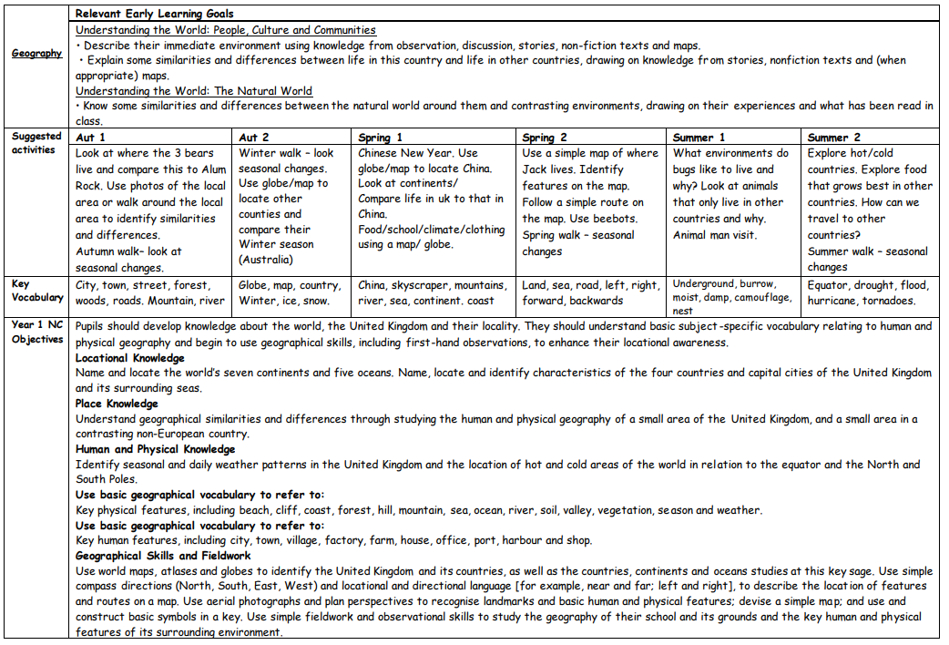
EYFS
YEAR 1 | YEAR 2 | YEAR 3
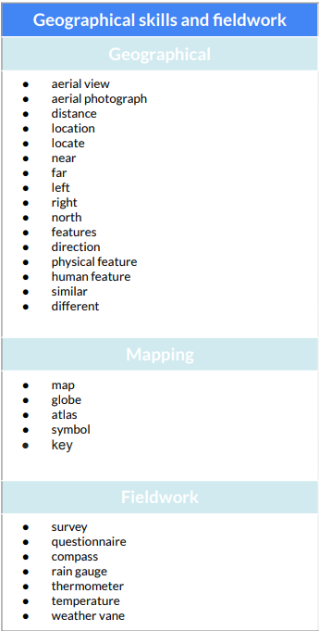
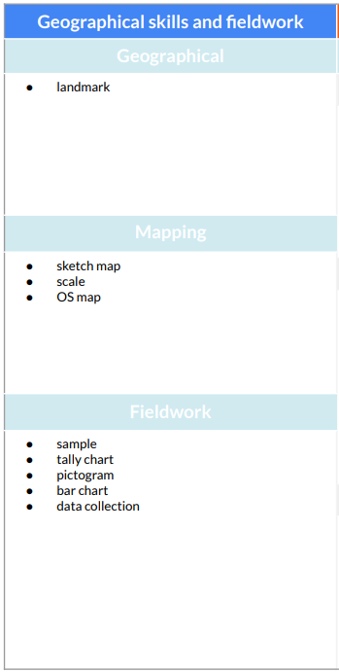
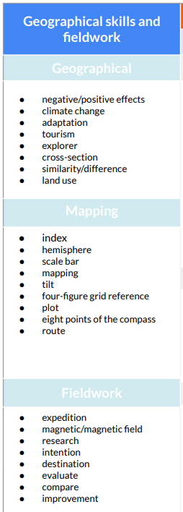

YEAR 4 | YEAR 5 | YEAR 6


