
St Saviour’s C of E Primary School
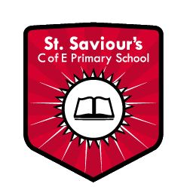
Phonics and Early Reading Policy


St. Saviour’s C of E school
Phonics and Early Reading Policy

At St Saviour’s, we believe that the ability to read and write confidently is a fundamental life skill that underpins all areas of learning. Phonics plays a vital role in the development of early reading, spelling and writing and is considered a key component of our approach to literacy across the school.
This Phonics Policy outlines our commitment to the systematic teaching of phonics; ensuring that all pupils are given the best possible foundation for becoming fluent, enthusiastic readers and writers. Within our school we follow a structured, progressive and inclusive approach to phonics teaching enabling children to develop secure knowledge of the relationships between sounds and letters and to apply this knowledge when reading and spelling.
This policy reflects current statutory requirements and guidance including the Early Years Foundation Stage (EYFS) Framework and the National Curriculum for English and supports our aim to meet the needs of all learners. Through high-quality teaching, regular assessment and timely intervention; we strive to ensure that every child, regardless of background or ability is supported to achieve success in phonics and beyond.

Why is phonics important?
High-quality, systematic synthetic phonics teaching is central to St Saviour’s approach to early reading and is delivered in line with the statutory requirements of the Early Years Foundation Stage (EYFS) Framework and the National Curriculum for English. This approach enables pupils to secure the essential skills of word recognition; including accurate decoding and blending, which are necessary for fluent and automatic reading. Once these skills are embedded pupils are able to direct their attention towards understanding and responding to the meaning of the text.
The Simple View of Reading, which underpins both the EYFS Framework and the National Curriculum identifies two distinct but interdependent dimensions of reading: word recognition and language comprehension. Both elements are essential for successful reading. As pupils develop secure and automatic decoding skills through systematic phonics instruction, the balance shifts from ‘learning to read’ to ‘reading to learn’. This progression supports pupils in reading with increasing fluency, confidence and enjoyment. The ultimate aim of reading instruction is for all pupils to achieve strong comprehension and a lifelong engagement with reading allowing them to comprehend, interpret and engage with a wide range of texts.
In accordance with statutory guidance, pupils are taught to develop a secure knowledge of grapheme–phoneme correspondences and to apply this knowledge when segmenting words for spelling. This systematic approach enables pupils to encode words with increasing accuracy and confidence, supporting effective reading and writing across the curriculum.
What programme do we use?
Here at St Saviour’s, we use Read Write Inc. (RWI) Phonics, a DfE-validated systematic synthetic phonics programme, as the core approach to teaching early reading and writing. The programme is designed to ensure that all pupils learn to read accurately and fluently with good comprehension, by developing secure decoding skills alongside a love of reading.
Most pupils complete the Read Write Inc. Phonics programme by the end of Year 1; however, where necessary the programme continues into Year 2 to ensure that pupils achieve secure phonics knowledge and reading fluency. Pupils in Years 3 and 4 who require additional support in phonics and early reading continue to follow the Read Write Inc. programme. In Years 5 and 6, pupils who are not yet secure readers access Read Write Inc. Fresh Start; a structured literacy intervention designed to accelerate progress for older struggling readers and enable them to read confidently and independently.
Read Write Inc. Phonics aims to:
- teach pupils to decode words rapidly and accurately using their phonic knowledge.
- develop fluency, prosody and automaticity in reading.
- ensure pupils understand what they read through structured comprehension and discussion.
- foster confidence, independence and enjoyment in reading.
Pupils are taught in progress-based groups which are organised according to their current reading attainment rather than age. Daily phonics sessions last 45 minutes (or 20–40 minutes in Reception, as appropriate), ensuring sufficient time for focused teaching, practice and application. Pupils are assessed regularly with formal assessments taking place at least half-termly enabling staff to monitor progress closely and move pupils between groups promptly so that teaching is closely matched to their needs.
In addition, to daily whole-group phonics teaching, targeted one-to-one or small-group interventions are provided for pupils who require additional support to maintain pace with the programme. These timely interventions are designed to prevent gaps in learning, support rapid catch-up and ensure that all pupils are given the opportunity to become confident, fluent readers.
Read Write Inc. (RWI) Phonics provides a structured and systematic approach to teaching reading, writing, and spelling, ensuring that all children develop secure decoding skills and confidence in literacy. Our approach is built on clear principles to support learning, engagement, and retention.
Phonics Instruction
Phonics is taught in a sequential, cumulative way to make learning accessible and enjoyable. Children learn to read and write the 40+ sounds in English, supported by visual cues such as pictures (e.g. ‘a’ as an apple, ‘f’ as a flower). Children then develop blending skills with Fred the Frog, who helps pupils combine sounds to read words.
Once basic phonics is mastered pupils learn alternative spellings for sounds (e.g., ‘ay’ as ay, a-e, ai; ‘ee’ as ee, e, ea) which are reinforced through memorable phrases. This systematic approach ensures children can decode unfamiliar words confidently.
To ensure children internalise what they learn, lessons are highly interactive. Pupils work in pairs to answer questions and discuss ideas; enabling teachers to check understanding continuously and provide immediate support where needed. Partner talk is embedded across the school day; maintaining focus and ensuring that all pupils can articulate their understanding clearly.
Reading Practice and Book Selection
During their phonics sessions children are provided with books that match their current phonics knowledge, enabling successful, independent reading. The selection of teaching books is determined by each group’s phonics assessment. Teachers are provided with guidance on the appropriate starting point within the series for example, whether to begin with Green Book 1 or Green Book 6 to ensure that instruction is accurately matched to pupils’ current phonics knowledge and reading ability. Each story is introduced with new vocabulary and character names and pupils read the story over three to five sessions (depending on their grouping); enabling decoding, developing fluency and comprehension. This approach ensures that by the time pupils read at home they do so confidently and with expression. Home reading books are to be issued every Monday at the end of your phonics session as this allows their book to be changed during the week with their TA.
Spelling and Writing
Spelling is taught using simple, consistent strategies. Pupils use Fred Fingers to segment regular words and Red Rhythms to learn tricky words, reinforcing retention through weekly practice and celebratory assessments.
Writing instruction is systematic: handwriting, spelling, and composition are taught separately and then integrated. Pupils learn correct letter formation, pencil grip, and posture from the outset, practise daily and gradually move from simple words to composing and proofreading sentences. Storybook vocabulary and structures are used to support composition and pupils are encouraged to verbalise sentences before writing to enhance clarity and memory.
Through this structured approach Read Write Inc. Phonics enables pupils to become fluent, confident readers and writers who can decode, comprehend, spell and write with independence and enjoyment.
How do we assess and track children’s progress?
To ensure that all children make the best possible progress in reading, assessments are conducted every half term. All children in Reception to Year 2 are assessed each half term. In Lower Key Stage 2, pupils who have not yet achieved the expected standard for reading at the end of Key Stage 1 are assessed to determine their needs. In Upper Key Stage 2, pupils at risk of not meeting the expected standard at the end of Key Stage 2 are assessed using the Fresh Start programme assessment enabling timely intervention and support. These assessments are carried out by the reading leader using an online assessment platform, which enables accurate placement of pupils within their phonics or reading groups. The platform also allows leaders and teachers to identify children who require additional support, enabling targeted daily one-to-one tutoring where necessary.
Grouping is based on word reading and fluency rather than comprehension, writing ability, or chronological age; ensuring that instruction is closely matched to each pupil’s reading development.
1 to fast-track tutoring.
Children at risk of falling behind are identified promptly to ensure they keep up rather than catch up from Reception onwards. Pupils making the slowest progress in Key Stages 1 and 2 receive daily 10-minute one-to-one tutoring in addition to their group phonics session. During these sessions, they practise rapid recall of sounds, blending skills and read a Storybook matched to their current phonics knowledge and reading ability.
What are the expectations of children’s progress on the Read Write Inc. Phonics programme?
After two years of implementation, it is expected that:
- Reception children will be able to read Green Storybooks by the end of the summer term.
- Year 1 children will be able to read Blue Storybooks by the end of the summer term.
- Year 2 children will have completed the Phonics programme by the end of the spring term.
We have high expectations for our children to meet the expected standard in the Phonic Screening Check and help all children to be accurate and fluent readers by the time they enter Key Stage 2.
See below RWI’s expectations from reception to the end of KS1.

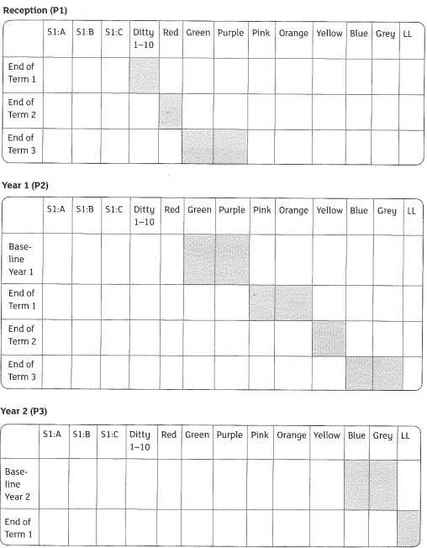

Parent partnership
We recognise the importance of parental engagement in supporting reading development and recognise that some of our pupils come from families where English is not the first language. To support and strengthen the connection between home and school learning, we provide accessible instructional videos on our school website, linked to YouTube. These resources enable parents to support their child’s learning at home and become familiar with the phonemes and sounds taught in school. Additionally, we provide parent reading workshops throughout the year, enabling parents to observe and practise the decoding, blending and comprehension strategies used in school. These initiatives strengthen home-school partnerships and equip parents to support their child’s reading fluency and comprehension effectively.
Pupils take home a phonics book each week which aligns with the sounds they are learning that week with fluent readers receiving an additional book for independent practice. For pupils in Key Stage 1, the online reading platform Bug Club provides interactive reading opportunities while Early Years children receive animated phonics lessons via Seesaw, reinforcing school learning at home. At St Saviour’s C of E primary school, we believe ‘Together Everyone Achieves More.’
How is the programme led to ensure these expectations are achieved?
The Reading Leader’s role is vital to ensure that the teaching of reading is of the highest quality and all children make progress.

‘Together Everyone Achieves More.’

