English
This term we will be focusing on:
Writing to Inform
Writing to Discuss
The writing outcomes will include:
- TV News Broadcast/ Script
- Informal Letter
- Explanation Text
- TV News Report
- Fantasy Narrative

Guided Reading

This term we will be reading:

The Cat Mummy

The Great Chocoplot

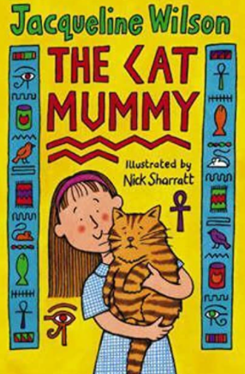

This curriculum map provides an overview of what your child will be learning across the curriculum this term. Wherever possible, learning will be linked to our focus topic.

Enrichment Opportunities

History – Egyptian Workshop

Maths
In Maths this term, we will be focusing on the following topics:

Number: Fractions (A) and (B)
Unit and non-unit fractions
Add, subtract and compare fractions
Equivalent fractions

Money
Pounds and pence
Add, subtract and convert money
Finding change

Time
Roman numerals up to 12
Tell the time using am/pm and digital clock
Hours, minutes, and seconds

Shape
Recognise and describe 2-D and 3-D shapes
Turns and angles
Horizontal, vertical, parallel and perpendicular

Statistics
Pictograms, bar charts, and representing data

Year 3 Curriculum Map
Summer
Topic: A Journey to Discovery!

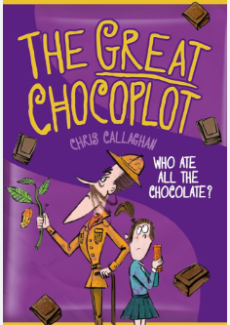

History
Children will learn about Ancient Egypt.

Science
The topics this term are ‘Animals including humans’ and ‘Plants’.

Design and Technology
Children will be making Egyptian Collars and
Vegetable tarts.

Computing
Children will be creating media for a video trailer (digital literacy) and understanding about data handling.

PE
In P.E, the children will be learning netball, circuit training and how to swim.

RE
Children will be exploring Hinduism (Hindu Beliefs and Pilgrimage to the River Ganges)

For the topics, the children will be exploring two key questions: ‘How can Brahman be everywhere and in everything?’ and ‘Would visiting the River Ganges feel special to a non-Hindu?’

RSHE
The topics this term are ‘Careers, Financial Capability and Economic well-being’ , ‘Physical health and well being’. Aswell as ‘KiVa’ – our school’s antibullying scheme‘.

Music
Children will be learning to keep rhythm and pace when singing. Children will learn a song called ‘Bringing us Together.’

MFL
In Modern Foreign Language, children will be learning phrases and vocabulary in Spanish.

